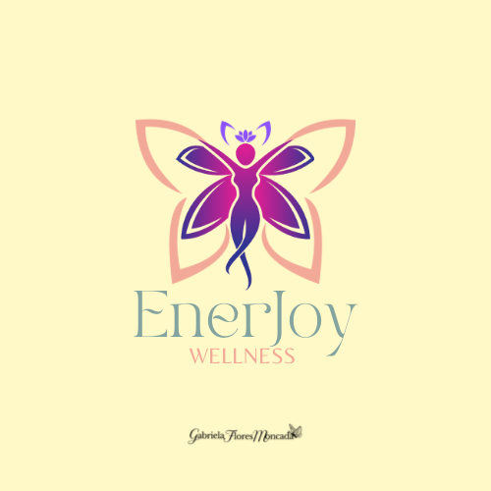 Got Questions? Email Me At Gabrielafloresmoncada@gmail.com

Quick and modern way of a very traditional Mexican hot chocolate but with a healthier twist and dairy free and using a blender instead of making the froth manually with a ‘molinillo’.

Dairy Free Mexican Hot Chocolate

Serves 2

Ingredients:
16 oz oat milk, preferably unsweetened
1 cinnamon stick
1 drop of cinnamon bark, vitality essential oil (optional)*
2 tsps. raw honey
2 Tbsp raw cacao powder (Mayan superfood)

Instructions:
In a qt saucepan warm the oat milk and 1 cinnamon stick until almost boiling.
Pour in a blender the milk mix. Add 1 drop cinnamon essential oil, raw cacao powder and honey.
Blend **
Serve hot
*I only use Young Living Vitality essential oils which are FDA approved for oral intake.
**Be careful when you blend the mix, because it is hot the lid make pop up so don’t fill the blender cup to high.
These products that I used, all together a cup of the hot chocolate is only 176 calories

Don’t forget to share your finished recipe on social media and tag @cookingsimplywithgaby
Raw cacao:
https://amzn.to/34lMcYy

